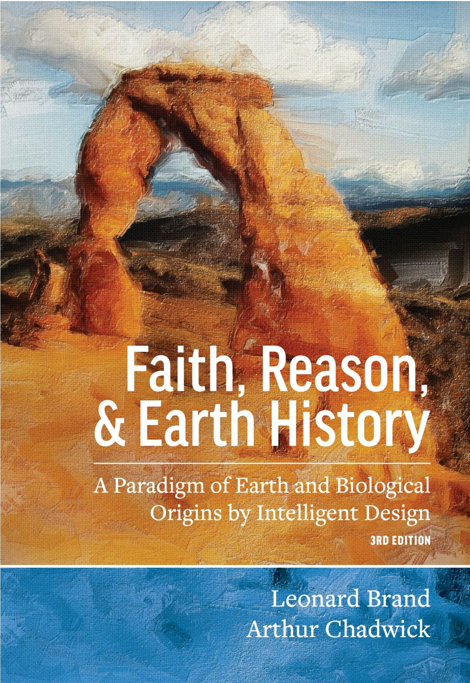
Promotions Packet for Partners – Faith, Reason, & Earth History 3rd addition
Help us spread the word about this FREE book! Thank you for your willingness to help. We hope to promote the relationship of science and the Bible both inside and outside the Seventh-day Adventist Church. We’re inviting you to become a social media ambassador for the Faith, Reason, & Earth History e-book by sharing to your fans and followers using #FaithReasonEarth. Please start sharing today! Below are some suggestions, pre-made posts, images, links, and email copy for your convenience.

What you can do to help!
- Email Your Contacts – Let your contacts, friends, students, and colleagues (where appropriate) know about the book. We suggest sending one email now inviting them to check out the webpage and promo video, as well as include a blurb in any upcoming newsletters from your organization (when appropriate) as a reminder. On the third page of this document, you’ll find some suggested email language to get you started.
- Visit our webpage to see the latest info, invite your friends, and share our content/videos.
  - www.adventistlearningcommunity.com/faith-reason-earth-history
- Twitter – Let your followers know about the book and use #FaithReasonEarth. Include a short URL (provided below) to the website. You can also include our promo images.
- Facebook – Post updates on your wall or share our updates to your friends and fans, and include the short URL (provided below). You can also include our promo images below and #FaithReasonEarth.
- Instagram – Post our promo image with either our pre-made post or a post of your own using #FaithReasonEarth and the short URL (provided below).
- Have another social media platform that you prefer to use? Feel free to use any of the below samples for your use.
- Most importantly – Pray that this publication can be a powerful opportunity to engage the world in a conversation on science, faith, and reason that glorifies God’s creative power and trustworthiness of the Bible.
__________________________________________________________________________________________________

Sample Tweets (feel free to adapt for your voice): Please remember to use #FaithReasonEarth & tag us @alc_nad. Use images to help your tweet stand out in the newsfeed.
- #FaithReasonEarth Available NOW for FREE! https://goo.gl/ZaBXgL (include image)
- Solid arguments for origins & history in the context of Scripture. #FaithReasonEarth Download FREE: https://goo.gl/ZaBXgL
- Showing readers how to analyze available scientific data & approach unsolved problems. #FaithReasonEarth. Details: https://goo.gl/ZaBXgL (include image)
- Faith need not fear the data. Understand earth history in the context of God’s word. #FaithReasonEarth FREE book: https://goo.gl/ZaBXgL

__________________________________________________________________________________________________
Sample Facebook post (feel free to adapt for your voice): Please tag us!
- Faith does not need to fear the data, but can contribute to understanding earth history within the context of God's Word while still being honest about unanswered questions. #FaithReasonEarth Available now for FREE: https://goo.gl/ZaBXgL (include image)
- Faith, Reason, and Earth History presents a powerful argument for constructive thinking about origins and earth history in the context of Scripture. #FaithReasonEarth Available now for FREE! https://goo.gl/ZaBXgL
Share this post on your wall and help spread the word! (include image)
- Showing readers how to analyze available scientific data and approach unsolved problems. #FaithReasonEarth Details & download FREE: https://goo.gl/ZaBXgL (include image)

__________________________________________________________________________________________________
Sample Instagram posts (feel free to adapt for your voice):
You can also update the link in your bio to make it easier for people to follow the link. Just add [link in bio] to your text.
- Showing readers how to analyze available scientific data and approach unsolved problems. #FaithReasonEarth Details & download FREE: https://goo.gl/ZaBXgL (include image)
- Faith does not need to fear the data, but can contribute to understanding earth history within the context of God's Word while still being honest about unanswered questions. #FaithReasonEarth Available now for FREE: https://goo.gl/ZaBXgL (include image)
- Faith, Reason, and Earth History presents a powerful argument for constructive thinking about origins and earth history in the context of Scripture. #FaithReasonEarth Available now for FREE! https://goo.gl/ZaBXgL Share this post and help spread the word! (include image)
Recommended Hashtags:
#adventist #sda #seventhdayadventistchurch #adventistchurch #sdalife #NADadventist #SDAchurch #creation #Christian #Christianity #godsword #faithandscience #creationism
__________________________________________________________________________________________________

Please include this link in all of your posts:
https://goo.gl/ZaBXgL

Press Release/Sample Email/Newsletter Copy: (Feel free to adapt for your own voice)
Suggested subject line: Faith, Reason, & Earth History by Dr. Leonard Brand and Dr. Art Chadwick available now online! #FaithReasonEarth
Headline: Check Amazon.com and iBooks for your free copy! #FaithReasonEarth
The third addition of Faith, Reason, & Earth History is now available in e-book form on Amazon.com and iBooks.
The ground is shifting. New research programs, and new discoveries, are constantly changing the landscape of our knowledge of "how it all began." And for those considering these matters from a position of biblical faith, there are new and promising frontiers to explore. Many of those remarkable recent changes are addressed in this fully updated third edition of this landmark work, now in its twentieth year of publication.
With additional contributions from joint author Arthur Chadwick, Faith, Reason, and Earth History presents Leonard Brand's continuing argument for constructive thinking about origins and earth history in the context of Scripture, showing readers how to analyze available scientific data and approach unsolved problems. Faith does not need to fear the data but can contribute to progress in understanding earth history within the context of God's Word while still being honest about unanswered questions. In this patient explanation of the mission of science, and its application to questions about origins and earth history, the authors model their conviction that "above all, it is essential that we treat each other with respect, even if we disagree on fundamental issues."
The original edition of this work (1997) was one of the first books on this topic written from the point of view of experienced research scientists. Brand and Chadwick, career researchers and teachers in biology and paleontology, bring to this well-illustrated book a rich assortment of practical scientific examples. This thoughtful, rigorous, and thoroughly up-to-date presentation makes this classic work highly useful both as a college-level text and as an easily accessible treatment for the educated lay person.

Download for FREE: https://goo.gl/ZaBXgL

More content on next page
And here are some images you can use for Twitter, Facebook, Email, and Instagram. Feel free to post your personal channels as well with #FaithReasonEarth
(Facebook and Twitter posts that include images are more likely to get noticed in your newsfeed)

